

[iPREP]Food Culture

SOI-2018-1810-0094

Date of Submission: 03-Aug-2018

Submitted By:

SOI-2018-0077

|  |  |
| --- | --- |
| 16007012 | Nur Atikah Binte Suhaimi |
| 16007713 | Nazreen Binte Ebrahim Yosuf |
| 16038028 | Syakir Mikhail |
| 16007343 | Tan Zhao Liang |

ACKNOWLEDGEMENTS

We are thankful for our supervisor Mr Toh Kee Heng for all the help that he had given us throughout the time whilst we are doing our project. He gave us a clearer view of the scope and what requirements we need to do to achieve that for our project as a whole including this report.

A special note and appreciation to our evaluators, Ms Grace Yap as well as Mr Juan Sng for giving out pointers for us to take when going through our Mid Term Evaluation.

This is a special acknowledgement for Ms Grace Yap for allocating our team for this project as it was a very fun and skillful project to have. It broadened our skills as well as our thought in completing the project. With this project, we have achieved skills and knowledge that were not taught to us within the parameters of the classroom and it certainly increased the value of our skills.

***Thank You to:***

***MS GRACE YAP***

***MR TOH KEE HENG***

***MR JUAN SNG***

**TABLE OF CONTENTS**

ACKNOWLEDGEMENTS 2

ABSTRACT 4

1 Introduction 5

2 Project Specification and Plan 6

2.1 Project Overview 6

2.2 Functional Requirements 8

2.3 Project Plan 8

3System Design and Implementation 9

3.1 System Architecture 9

3.2 Detailed System Design 9

4System Testing 10

5User and Technical Documentations 11

5.1 User Documentation/Guide/Manual 11

5.2 Technical Documentation (Installation guide/Manual) 11

6Conclusions 12

References 13

Appendices 14

Project Poster 15

# ABSTRACT

Food culture is a web application that allows tourist from all around the world to have a first hand interactive cultural experience hosted by a Singaporean themselves in their homes. Through this application, the tourist is able to gain this experience simply by booking a time and date and wait for the host to accept their request. The host also has the opportunity to meet new people from a different background without leaving the country. Apart from that, the host can use this opportunity to gain more revenue from their paid hospitality.

This project is being implemented through various languages such as HTML5, PHP, CSS, and Javascript. By using HTML5 and CSS, we are able to create our User Interface to make it look as attractive as we possibly could. PHP and Javascript were used in allowing us to code out the functions that help to run the application as the back-end. With all of these languages integrated together, we were able to design and create a functioning web application.

# Introduction

Food Culture web application allows people from different background and culture to experience the local culture of Singaporeans. This app is providing this service that is different from what is usually being implemented in this country; an example would be Airbnb. Instead of the guest staying in a host’s accommodation and explore the country by themselves, this app eliminates the hassle of the guest going around to get the feel of the culture in Singapore by allowing the guest to spend the day with the host themselves through a meal session. This create a more meaningful experience for both the guest and the host as through a meal session, they are able to communicate and create a bond that they can’t get if they were to go on a holiday by themselves.

This project delivers to allow the guest to make a booking at any region of singapore and allows the host, within the region or out of it if the guest willing, to make an offer for them to visit their homes. Due to the fact that this application allows people of different country to make a booking, paypal was the payment gateway that was implemented in this project. It is a universal payment method as well as an easy payment system to sign up for.

# Project Specification and Plan

## Project Overview

* **Project Motivation:**

The application will allow tourists from anywhere around the world to have an interactive cultural experience of Singapore where it is hosted by Singaporeans themselves in their own home. Nonetheless, the host would also not miss out on getting to meet new people from different background and get paid for their hospitality towards the tourists.

* **Project Objectives:**

The project aims to provide tourists a convenient and safe way to experience authentic Singaporean food, and connecting hosts with tourist seamlessly through the webapp.

* **Project Scope:**
* Creating a website that allow
  + Request experience
  + Register as guest
  + Register as host
  + Host and Guest matching
  + Choose Host
  + Make Payment
  + Arrange meeting logistics
  + Rate experience
  + Integration with external payment gateway
  + View Bookings
* **Project Assumptions:**
* Host receive the Camera from the company to capture the image of the Guest when they arrive.
* PayPal can retrieve payment information from the website to the gateway
* System able to do face detection and recognition for the verification of the guest for security purposes.

## Functional Requirements

* **Use Case Diagram:**

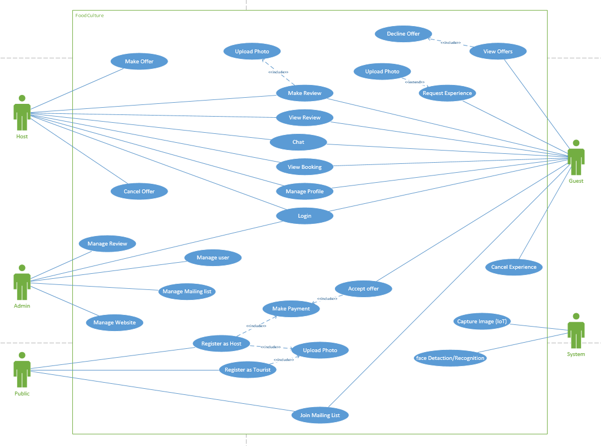

## Project Plan

* **Gantt Chart**

**

# System Design and Implementation

## System Architecture

This web application is running on a cloud-computing webform that communicates with MySQL call Amazon Elastic Compute Cloud allowing the connection of the application with the cloud database. PHP was initiated as the major language for the application backend services with the help of javascript and ajax to build a more stable web application. Raspberry-pi was also used to allows the connection of the camera to the desktop and pushing it to the cloud platform to be able to be retrieved through the application.

## Detailed System Design

* **Entity Relationship Diagram**

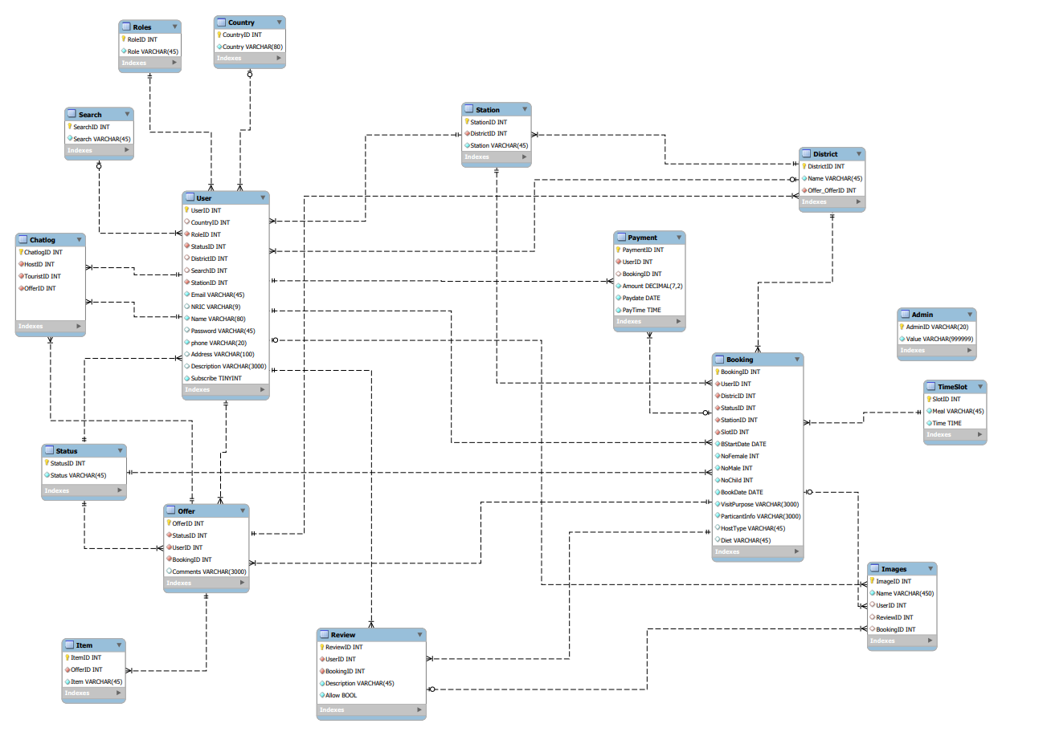

* ***Use Case Specification***



# System Testing

The attachment below are the System Test Care:



# User and Technical Documentations

## User Documentation/Guide/Manual

**Guide for Public**

To allow the public to join the mailing list to receive updates on the application:

* Visit the application main page
* Click on “Mailing List”
* Enter their particulars such as Email Address, Full Name, how did they found out about us and the Country where they are from
* Click “Submit” and any updates or promotion sent out will be received.

To allow the public to register as a Host:

* Visit the application main page
* Click on “Register” and then “Register as Host”
* Fill in their particulars in the form and submit
* It will move on to the redirection age where they need to make a registration fees of $40
* Payment is made through PayPal
* Page returns to main page

To allow the public to register as Tourist:

* Visit the application main page
* Click on “Register” and then “Register as Guest”
* Fill in their particulars and press submit
* It will redirect to the Login page

**Guide for Guest**

To allow the Guest to make Booking;

* At the main page, click “Login”
* Key in the email address and password to login
* After logging in, click on “Make request”
* Fill in the form with the desired location and timing to meet the Host
* After confirm booking, wait for the Host to make any offer

To allow the Guest to accept or decline the offer:

* After logging in, click “View Offer”
* There will be a list of bookings with different offer status
* Go to any booking with offer, click “View Offer”
* Offer details will be listed there
* Guest can then accept or decline the offer
* If accept:
  + They will go to the payment page where they will make the payment for their booking
* If decline:
  + They will be brought back to the View Offer page and offer declined will be removed from the list.

To allow the Guest to chat with the Host:

* In the “View Offer” page, there will be a green button call “Chat”
* Click on “Chat” and the Guest can start to enquire more to the Host that made the offer.

**Guide for Host**

To Allow the Host to Make Offer:

* At the main page, click “Login”
* Key in the email address and password to login
* After logging in, click on “Make Offer”
* Fill in the form for the particular booking and wait for the Guest to accept or decline the offer to them

To allow the Host to Inactive:

* After logging in, click on “Edit profile”
* In the editing profile page, the Host are able to edit any of their particulars except their NRIC.
* After changing their status from “Active” to “Inactive”
* Click “Update”
* Host with an Inactive status will not be allowed to make any offer not the can see any bookings made near their location.

**Guide for Administrator**

To allow creation of another admin:

* Going to the same main page, click “Login”
* Clicking the “Manage Users” will allow the Administrator to view all the users in the system.
* Click on the “Create New Admin” and it will bring you to a form page the current Administrator can create a new Admin.
* After filling out the form, click “Create” to create the new admin; it will redirect back to the Manage User page.

To allow the Admin to send out promotions to users agreed to be on the mailing list:

* After logging in, click “Manage Mailing List”
* It will show a list of users that agreed to be subscribed for the mailing list
* A button will be at the top called “Send Email”; click the said button
* It will then move to a page where the Administrator can create the Email plus, sending an attachment as well.
* Once done, click “Send” and the email will be sent to those under the mailing list.

# Conclusions

A wrap up of this project is that as team, we have managed to create the web application with the functions that was planned to make this project successful. The connection to the cloud database was also a success given that anyone who’s on the application on different device and on the same timing will be able to see the changes or updates made. Even though we have covered most of the functions, if we were to be given more time to work on this project as an extended project, we will use that as an enhancement such as the Interface/Design of the website as well as functions such as categorise the chats so that the user will be able to see all the chat at one page, allow for the review to be written with bold/italics, recognition of foul words in the review submission and easier access of the links in the index page. Even though we struggled with the first 2 languages that was Ruby on Rails and JavaScript Node.js, and started using PHP at the last minute, our progress was more than was what done as compared with the previous 2 languages.

# 

# References

* **Acknowledge** any work, statement or definitions copied
* Citation **style**
  + Codexworld (2017) Integration with paypal
    - https://www.codexworld.com/paypal-standard-payment-gateway-integration-php/
  + Amazon EC2 Cloud Computing
    - <https://docs.aws.amazon.com/AWSEC2/latest/UserGuide/concepts.html>
    - <https://docs.aws.amazon.com/AWSEC2/latest/UserGuide/putty.html?icmpid=docs_ec2_console>
  + PHPMailer with Gmail
    - <http://codingpassiveincome.com/phpmailer>
  + Web Application with PHP as Backend
    - <https://www.w3schools.com/php/php_examples.asp>
    - <https://www.w3schools.com/php/php_ajax_php.asp>
    - <https://www.youtube.com/watch?v=JaRq73y5MJk>
  + Raspberry Pi 3 (IOT) with PiCamera
    - <https://www.youtube.com/watch?v=oM2zVD9rL8I&t=302s>
    - <https://www.youtube.com/watch?v=qk1IVs5B1GI>
  + Drop down ajax
    - <https://www.youtube.com/watch?v=_zZ-3JERK8g>
  + Facial Recognition with nodejs
    - <https://redstapler.co/face-detection-javascript/>
    - <https://github.com/jaysalvat/jquery.facedetection>
    - <https://trackingjs.com/>

# Appendices

Appendix A:

1. Entity Relationship Diagram

# Project Poster

**